**Create a Simple JSX Element**

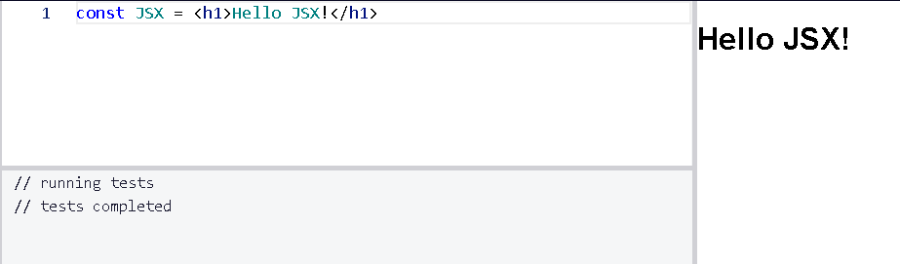

**Create a Complex JSX Element**

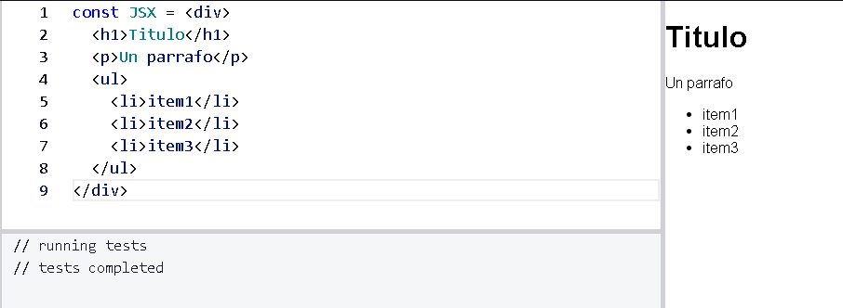

**Add Comments in JSX**

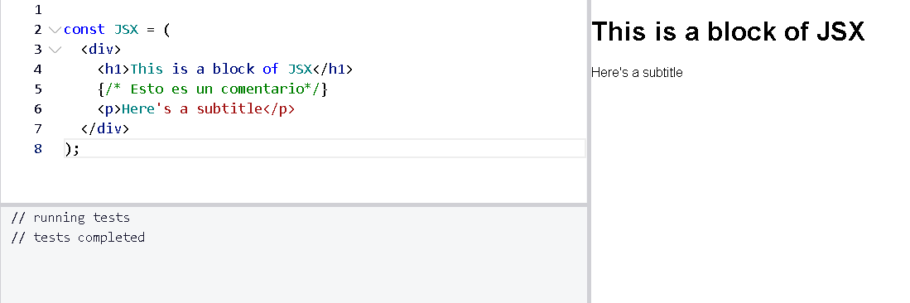

**Render HTML Elements to the DOM**

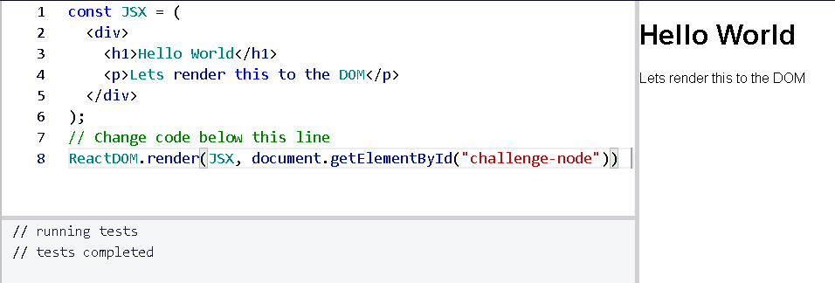

**Define an HTML Class in JSX**

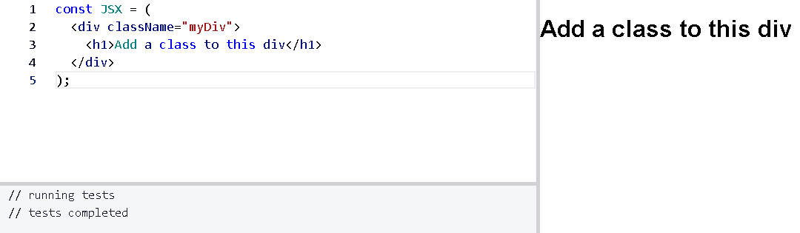

**Learn About Self-Closing JSX Tags**

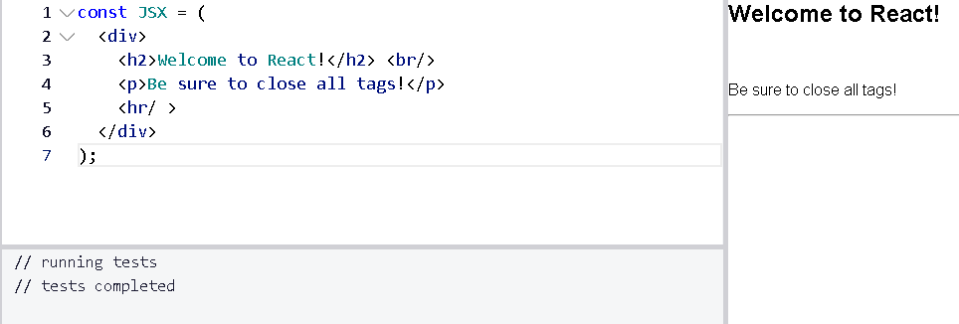

**Create a Stateless Functional Component**

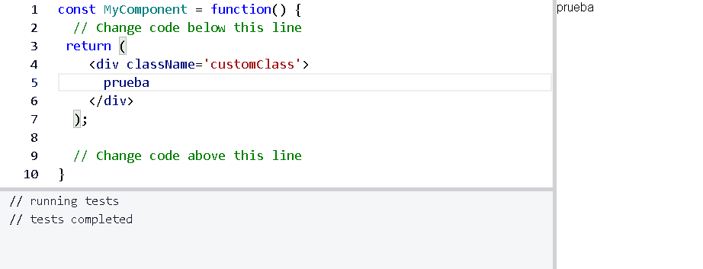

**Create a React Component**

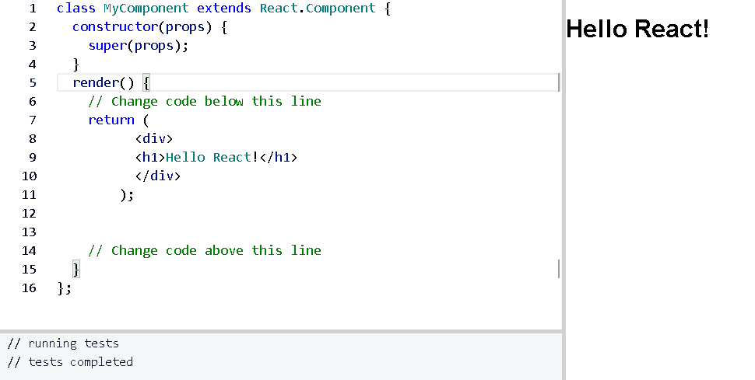

**Create a Component with Composition**

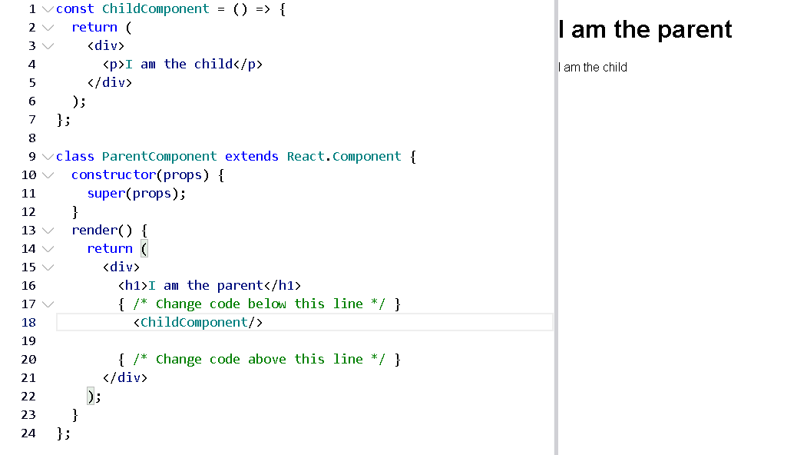

**Use React to Render Nested Components**

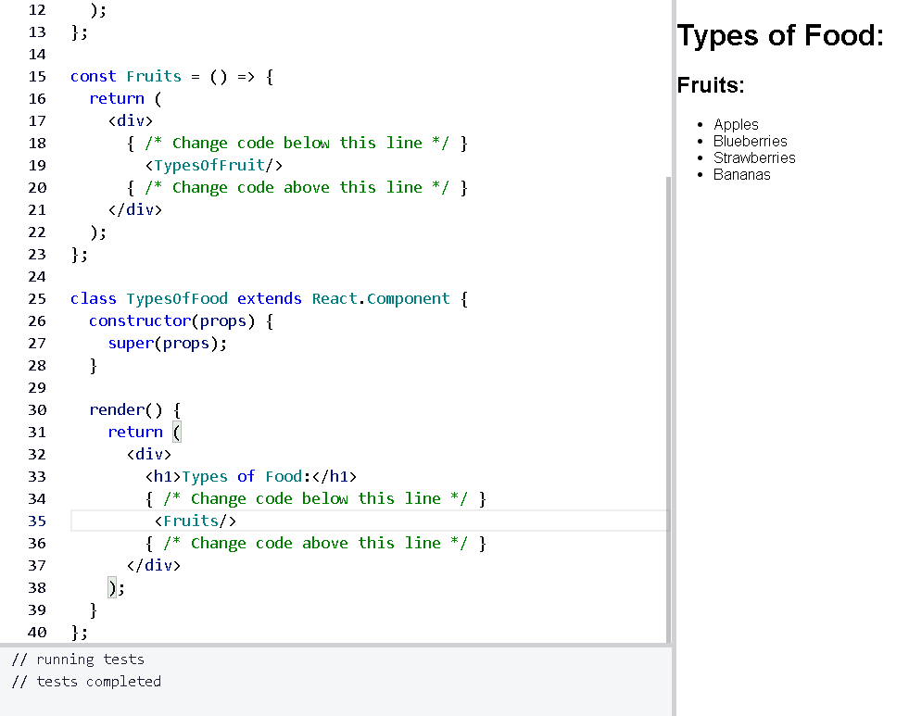

**Compose React Components**

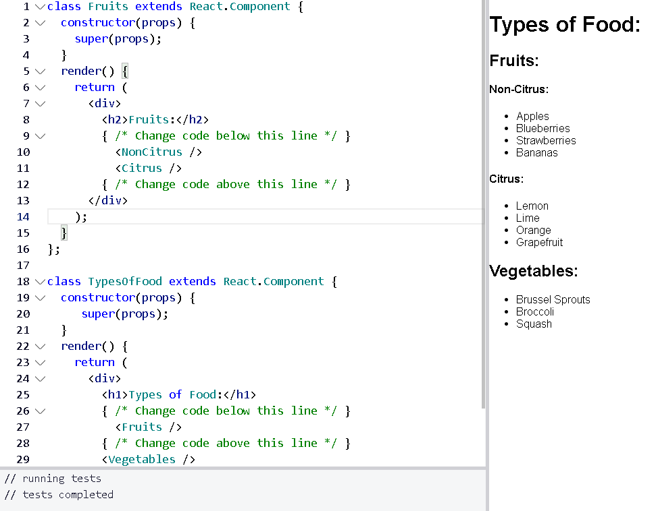

**Render a Class Component to the DOM**

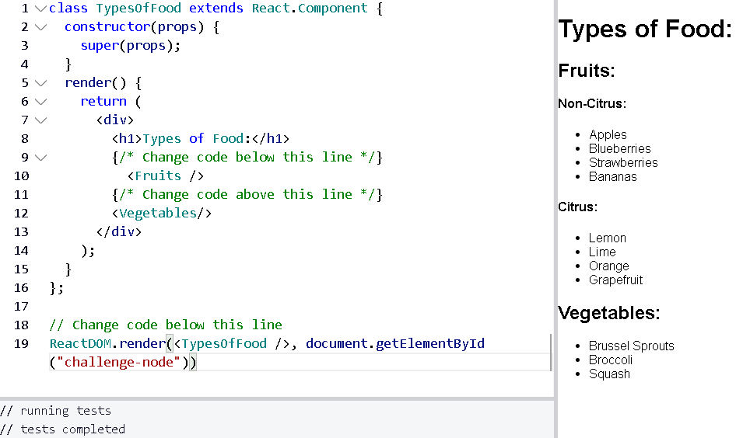

**Write a React Component from Scratch**

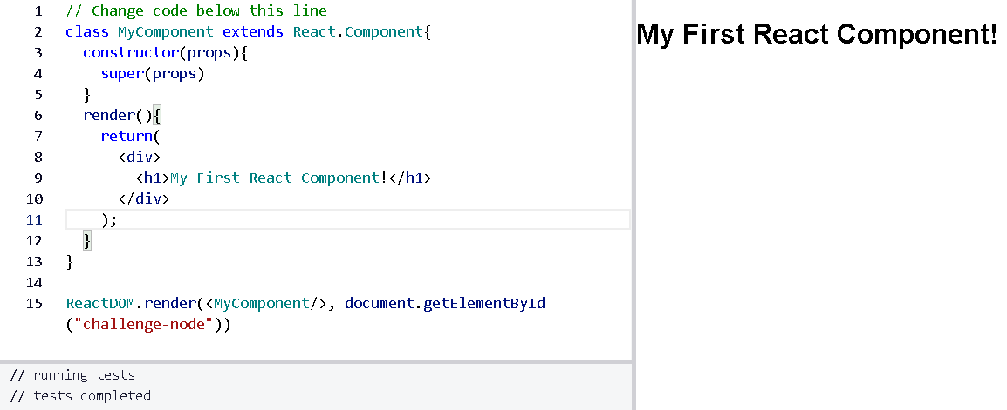

**Pass Props to a Stateless Functional Component**

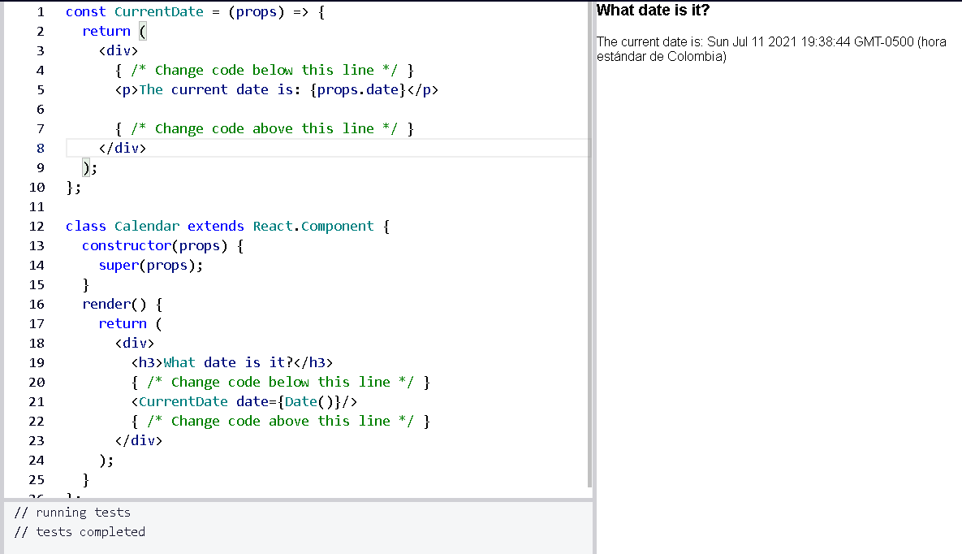

**Pass an Array as Props**

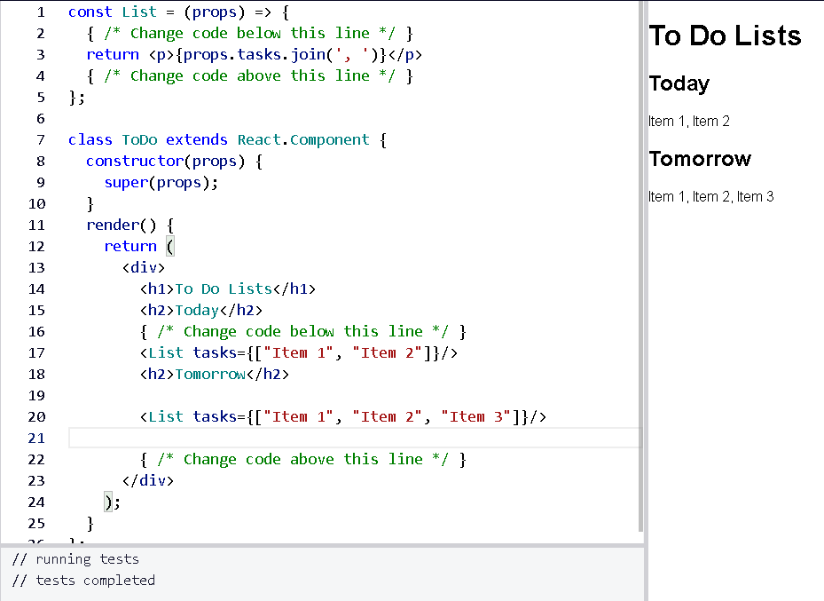

**Use Default Props**

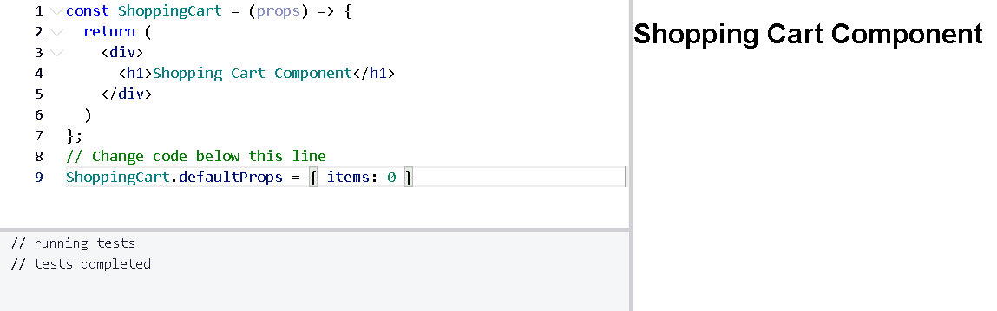

**Override Default Props**

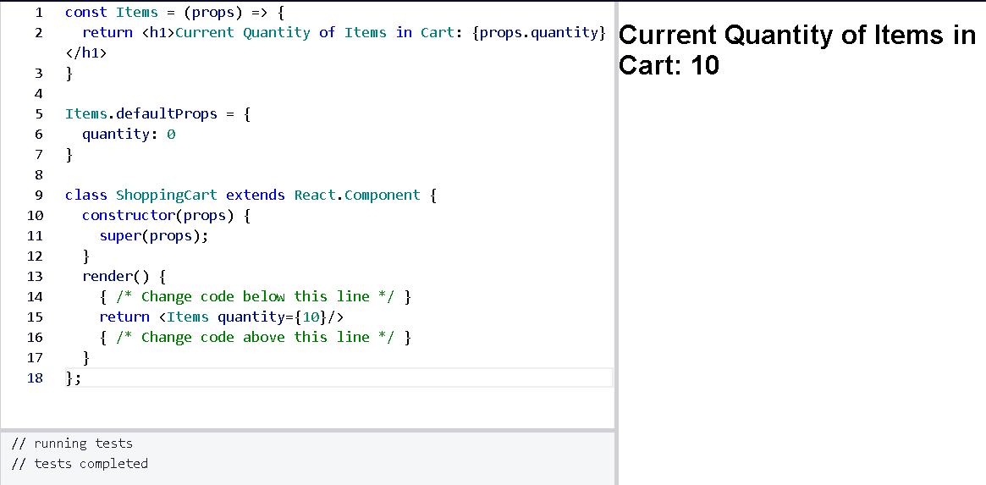

**Use PropTypes to Define the Props You Expect**

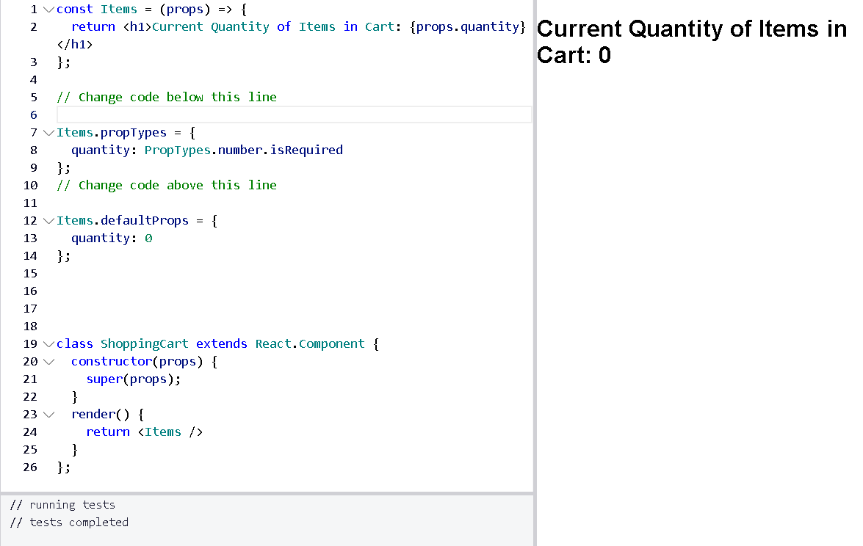

**Access Props Using this.props**

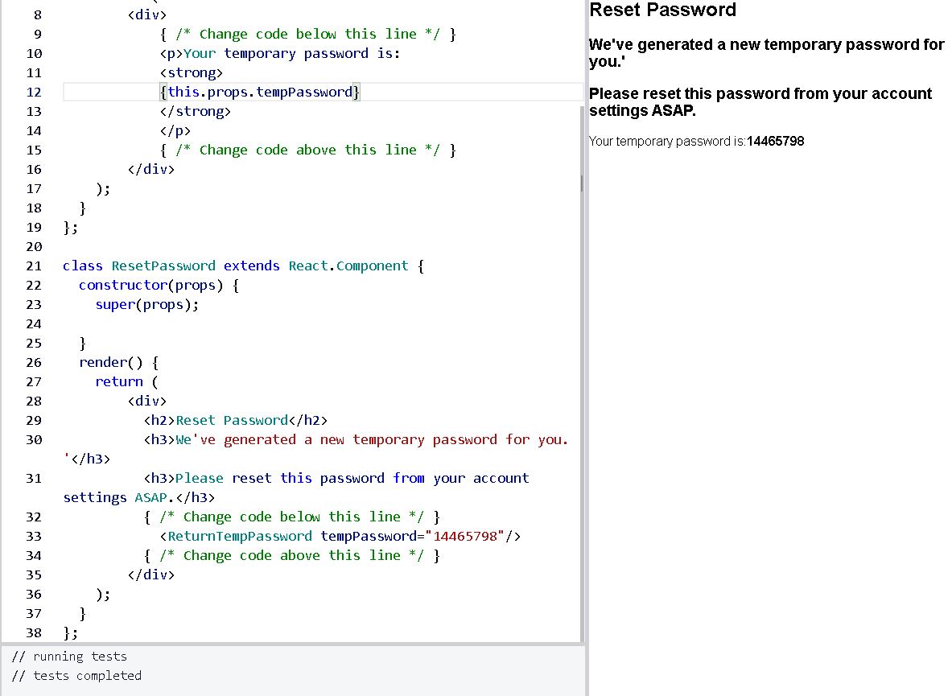

**Review Using Props with Stateless Functional Components**

